What is Gradle?

- Gradle is a dependency manager and build tool known for its flexibility in building software applications.
  - We’ll be using Gradle to create more powerful applications. This “power” comes from external libraries that Gradle lets us install, called “dependencies”.

- Dependency manager? This alludes to Gradle letting us import outside code, AKA dependencies, to add more capabilities to our apps.
  - We’ll see libraries like JDBC, JUnit, and Logback soon, plus some more later.

- Build tool? We’ll see this way later, but Gradle makes it easy to package applications into a publicly deployable format. So it’ll come in handy when our apps go live.

- The main config file for any Gradle project is build.gradle. This is where we can set metadata like the name of the app, java version, and dependencies we want in our app.

It’s simple to create a Gradle project in Intellij. Just choose “Gradle” when making a new project.
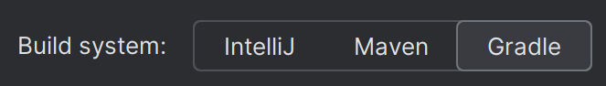

Gradle Scripts, Tasks, and Plugins

- Scripts - Gradle scripts define our build logic, which is the set of instructions Gradle follows when compiling or building your project. When we create a new Gradle project, we get the build.gradle script automatically. All we'll do with it for now is import dependencies.
  - BTW, we “build” a project to turn it into a single, publicly deployable file. Don’t worry about this yet - we’ll see it in a couple months.
- Tasks - A Gradle task is a “single atomic unit of work”. Gradle has a bunch of built in tasks for compiling code, running tests, packaging an app (to deploy it publicly) etc. We’ll see a lot of these tasks when our apps go live. Some common ones we’ll see include gradle clean, gradle build, and gradle run.

- Plugins - You can think of a Gradle plugin as a set of tasks that can be reused in different projects. We can write our own plugins, but there are lots of built in Gradle plugins that supply common sets of tasks. For instance, the Java plugin is automatically included in a Java/Gradle project.
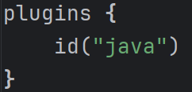
Below are some dependencies we’ll can use for testing (JUnit/Mockito) and logging (LogBack)--

JUnit (for unit testing)

- Unit testing tests the smallest units of code (for Java this will be methods) to ensure that they’re functioning as intended.
- Generally, tests can be positive or negative tests, and you should have both.
  - Positive tests give an expected/valid input and test to see if the expected return occurs.
  - Negative tests take an invalid/unexpected input set and if your code handles it correctly.
- JUnit is a testing framework that provides annotations and methods for creating unit tests. It’s one of the most used testing frameworks for Java, and included in Gradle projects by default.

- When writing tests in JUnit, there are specific methods that will allow you to test the results of your methods. These are “assertion types”. Some common ones:
  - assertTrue() - test some expression on whether it returns true or not
    - n = someMethod(8);
    - assertTrue(n == 8);
  - assertFalse() - assert that a boolean value of false is returned
  - assertEquals() - tests that the method output is equivalent to some value
  - assertNotEquals()
  - assertNull()
  - assertNotNull()
  - assertThrows() - tests for exceptions, (requires the use of a lambda function)
  - assertThat() - this is a generic assertion - you must define its functionality

- There are also some JUnit Annotations that change the behavior of your test suite:
  - @Test – Labels a method as a test method to be run when testing occurs.
  - @BeforeAll – Runs this method before any tests in the class are run. Requires a static method.
  - @AfterAll – Runs the method once after all tests have run.
  - @BeforeEach – Runs every time before a test method runs.
  - @AfterEach – Runs every time after a test method is run.
  - @Ignore – will tell a test not to run.

Testing Strategies (TDD, AAA, Line vs Branch Coverage)

Test Driven Development (TDD)

- The TDD process consists of writing unit tests first, before the application code has been written. Then, code can be written to make the tests pass and the process can be completed for each piece of functionality in the application.

- Write a unit test
- Run the test => test will fail
- Fix the test by writing application code
- Retest until the test passes
- Repeat
- Following the TDD process can be useful for ensuring that a valid unit test always exists for any class or method that is written.
- Later, when refactoring code, the unit tests give us confidence that our changes to the source code didn’t break existing functionality. If we mess up the code, certain unit tests will fail. This makes it easier to pinpoint what we broke.
Arrange, Act, Assert (AAA)

- This is a good way to think about how to write tests. It break the process into 3 steps:
  - Arrange: Perform setup needed for the tests. This includes @Before/After logic, object instantiation, or file/data imports.
  - Act: Perform the main operations of the test - invoking the functionality that we’re actually trying to test.
  - Assert: This is where we actually test the outcome of the “Act” stage. Call one or more assert() functions to determine if the behavior is expected or not, which determines if the test passes or fails.

Line and Branch Coverage

- Code coverage is a metric that measures how much of your code is covered by your tests. If every single line in your code base is executed in your test suite, you’ve achieved 100% test coverage.
  - Keep in mind that 100% test coverage doesn’t necessarily entail EFFECTIVE testing… just means all your code was executed at some point during the tests.

- Line Coverage reflects the amount of code that has been executed based on the amount of compiled Java code that gets run by your tests. This is the traditional “lines of code” metric.

- Branch Coverage is more about the amount of different “branches” that have been covered in your tests. Branches are the different outcomes of control flow statements. (if/else, switch, try/catch)... Have you tested each possible outcome of your conditional statements? Or have you only tested what happens when things go right?

Stuff we may not get into but worth knowing (popular gradle dependencies)

Logging (With Logback)
- Logback is a reliable, fast, and flexible logging framework for Java supported by Apache. It's commonly used to record application events, log debugging information for developers, and write exception events to files.
  - It’s the replacement for its predecessor, Log4j
- Why do we need logging?
  - Logs record events that occur during software execution.
  - Without logs, we have a harder time determining what went wrong when an application crashes. It also helps us catch potential security risks.
- Also, a logging framework like Logback is critical because it allows us to use various logging levels to determine which messages will be recorded in the application log files.
- Below are the Logback log levels, in order of least to most restrictive:
- ALL => all levels (Including TRACE, which DEBUG doesn’t include)
    - Note: TRACE isn’t used too much, it’s considered too verbose
- DEBUG => designates fine-grained informational events that are useful when debugging. Mostly used during development, not production.
- INFO => informational messages that highlight the progress of the application.
- WARN => designates potentially harmful situations
- ERROR => designates error events that might still allow the application to continue running
- FATAL => severe error events that presumably lead the application to abort
- OFF => highest possible level, intended to turn off logging
- Lastly, a logger can be assigned a threshold level, so that all logging levels lower than the specified threshold will be ignored.
  - For example, setting the logger threshold to INFO means that logging requests with levels DEBUG will not be logged by this logger.
  - DEBUG is the default threshold level

- To use logback, we need a gradle dependency and a config file called logback.xml in src/main/resources.
Example logback.xml file – This one is configured to print logs in the console as well as write logs to a file that we’re calling logback.log
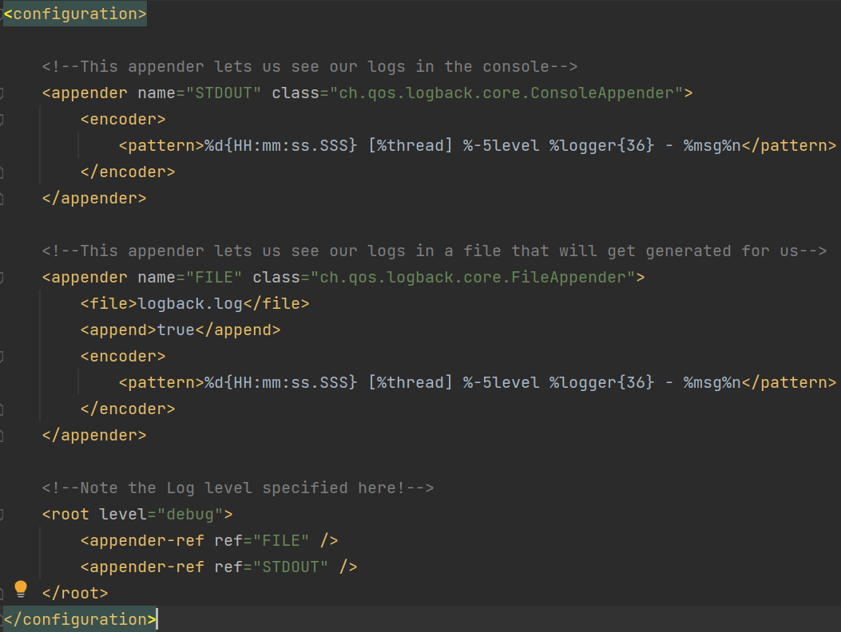
*I wouldn’t try to copy this down in your own project - just steal it from somewhere or ask AI
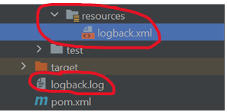 Note: The logback.log file gets created automatically
- Once your configurations are in place, using Logback is easy:

- First, you need a Logger object
- Then you can use it to generate logs anywhere in your source code
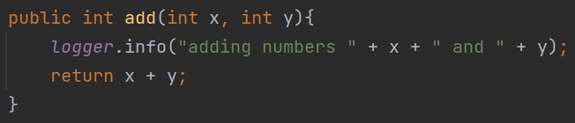

*NOTE: You may hear about “log4j” instead of logback. They are pretty much identical in practice, and logback is the successor to log4j. So I made the executive decision to show logback instead. If you see “log4j” in an exam or at work, don’t panic. They behave pretty much the same, and they use the same main entities.

Mockito Overview

- Mockito is another java testing framework that goes hand in hand with JUnit. It makes our unit tests more powerful with a strategy called mocking.
  - Mocking is essentially creating a dummy object called a “stub” that simulates the behaviors of a real object. This allows us to call the methods of a class without having to create real objects of that class. The stub that gets created will act as a fake object whose methods return values that we define.
    - Imagine you’re testing methods that manipulate a database (which we’ll be doing very soon). You may find yourself adding meaningless data or changing/deleting important data when running those tests! It would be better to use mocking for our testing needs so we can test the methods via a stub without actually using an object that hits the database.

- By the way, mockito is typically used for integration tests, which is testing the behavior of multiple methods working together. In other words, testing the "integration" of two or more methods. This is in contrast to unit tests, which just test single methods.

